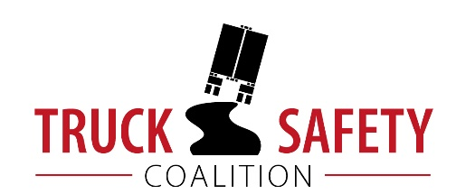

Parents Against Tired Truckers and Citizens for Reliable and Safe Highways

FACTS ABOUT THE DANGERS OF
LARGE TRUCKS IN OKLAHOMA

- Between 2011 and 2015, there were 588 fatalities in crashes involving large trucks in Oklahoma. (FARS)

- Large trucks were involved in 16% of fatal crashes in Oklahoma in 2015. (FARS)

- Motor vehicle crashes cost Oklahoma $3.29 billion a year, approximately $876 per capita. (NHTSA 2010)

- Twenty-three percent (23%) of Oklahoma's bridges are structurally deficient or functionally obsolete. (TRIP 2016)

- Thirty percent (30%) of Oklahoma’s major roads are in poor condition. (TRIP 2016)

- Driving on roads in need of repair costs Oklahoma motorists $2 billion a year in extra vehicle repairs and operating costs -- approximately $810 per motorist. (TRIP 2016)

KEY:
FARS = Fatality Analysis Reporting System 2011-2014 Final, 2015 ARF
NHTSA = National Highway Traffic Safety Administration, The Economic Impact of Motor Vehicle Crashes
TRIP = The Road Information Program

