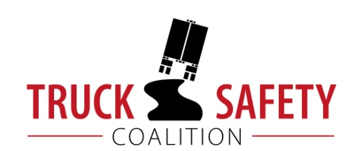

Parents Against Tired Truckers and Citizens for Reliable and Safe Highways

FACTS ABOUT THE DANGERS OF
LARGE TRUCKS IN NORTH DAKOTA

- Between 2011 and 2015, there were 247 fatalities in crashes involving large trucks in North Dakota. (FARS)

      - Large trucks were involved in 36% of fatal crashes in North Dakota in 2015. (FARS)

- Motor vehicle crashes cost North Dakota $807 million a year, approximately $1199 per capita. (NHTSA 2010)

- Twenty-one percent (21%) of North Dakota’s bridges are structurally deficient or functionally obsolete. (TRIP 2016)

- Ten percent (10%) of North Dakota’s major roads have pavements in poor condition. (TRIP 2016)

- Driving on roads in need of repair costs North Dakota motorists $186 million a year in extra vehicle repairs and operating costs – approximately $353 per motorist. (TRIP 2016)

KEY:
FARS = Fatality Analysis Reporting System 2011-2014 Final, 2015 ARF
TRIP = The Road Information Program
NHTSA = National Highway Traffic Safety Administration, The Economic Impact of Motor Vehicle Crashes

