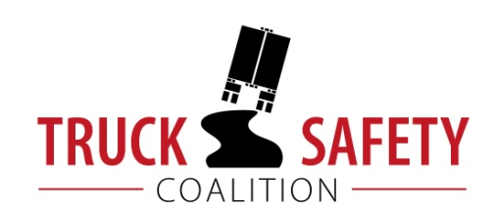

Parents Against Tired Truckers and Citizens for Reliable and Safe Highways

FACTS ABOUT THE DANGERS OF
LARGE TRUCKS IN NEW JERSEY

- Between 2011 and 2015, there were 298 fatalities in crashes involving large trucks in New Jersey. (FARS)

- Thirty-eight percent (38%) of New Jersey’s public roads have pavements in poor condition. (ASCE 2016)

- Thirty-five percent (35%) of New Jersey’s bridges are structurally deficient or functionally obsolete. (TRIP 2016)

- Driving on roads in need of repair costs New Jersey motorists $3.9 billion a year in extra vehicle repairs and operating costs--approximately $632 per motorist. (TRIP 2016)

- Motor vehicle crashes cost New Jersey $14.9 billion per year, approximately $1689 per capita. (NHTSA 2010)

KEY:
ASCE = American Society of Civil Engineers Report Card for America’s Infrastructure
FARS = Fatality Analysis Reporting System 2011-2014 Final, 2015 ARF
NHTSA = National Highway Traffic Safety Administration, The Economic Impact of Motor Vehicle Crashes
TRIP = The Road Information Program

