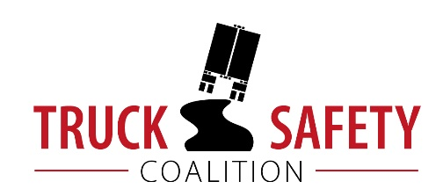

Parents Against Tired Truckers and Citizens for Reliable and Safe Highways

FACTS ABOUT THE DANGERS OF
LARGE TRUCKS IN NEVADA

- Between 2011 and 2015 there were 115 fatalities in crashes involving large trucks in Nevada. (FARS)

- Driving on roads in need of repair costs Nevada motorists $812 million a year in extra vehicle repairs and operating costs -- approximately $452 per motorist. (TRIP 2016)

- Thirteen percent (13%) of Nevada’s bridges are structurally deficient or functionally obsolete. (TRIP 2016)

- Fourteen percent (14%) of Nevada’s major roads have pavements in poor, mediocre, or fair condition. (TRIP 2016)

- Motor vehicle crashes cost Nevada $1.9 billion per year, approximately $938 per capita. (NHTSA 2010)

KEY:
FARS = Fatality Analysis Reporting System 2011-2014 Final, 2015 ARF
TRIP = The Road Information Program
NHTSA = National Highway Traffic Safety Administration, The Economic Impact of Motor Vehicle Crashes

