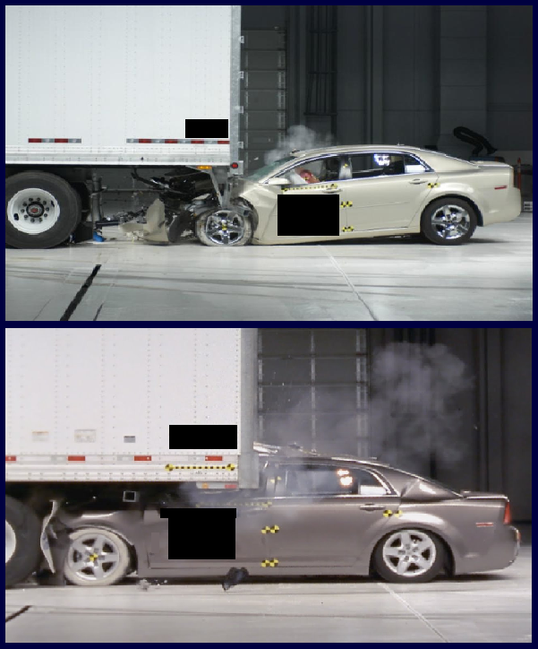
REAR UNDERRIDE CRASH

SIDE UNDERRIDE CRASH
Rear/ Side Underride and Front Override Guards

The federal government should require all trucks and trailers to be equipped with energy-absorbing rear, side, and front underride guards to protect car occupants from underride crashes. These crashes can be catastrophic because the car rides under the trailer, bypassing the crumple zone and airbag deployment sensors; in severe collisions, passenger compartment intrusion occurs. The safety benefits of underride guards are proven and well known. In fact, five of the eight leading trailer manufacturers have developed rear underride guards that qualify for the Insurance Institute for Highway Safety’s (IIHS) ToughGuard rating, which greatly exceeds the proposed federal standard by preventing underride crashes at 100, 50, and 30 percent overlaps at 35 mph.

For several years, the National Transportation Safety Board (NTSB) has issued multiple recommendations for improved rear underride guards, for side underride protection systems, and front underride guards. In addition, NTSB identified the need for improved data collection, including vehicle identification numbers to better evaluate trailer design and the impact on safety.

On July 10, 2014, the National Highway Traffic Safety Administration (NHTSA) announced it would grant the petition brought by Truck Safety Coalition (TSC) and the Karth family to issue a Notice of Proposed Rulemaking (NPRM) for rear underride guards on trailers. Additionally, NHTSA has started an Advanced Notice of Proposed Rulemaking (ANPRM) for rear guards for single unit trucks, and will continue to evaluate side and front guards.

Rear Underride Crashes:

NHTSA reported that large truck rear impacts comprised 22 percent of fatal two-vehicle collisions between large trucks and passenger vehicles during 2015. IIHS crash tests demonstrated that the rear underride guards mandated for trailers by NHTSA in 1998 performed poorly, and that there are available underride guards that far exceed the proposed force requirement by up to 70 percent.

Side Underride Crashes:

NHTSA has reported that large truck side impacts comprised 17 percent of fatal two-vehicle collisions between large trucks and passenger vehicles during 2015. One reason why collisions with the sides of tractor-trailers are hazardous is that there is a large area of the trailer where underride may occur during these collisions. In addition, bicyclists and pedestrians are particularly vulnerable to side underride interactions because of their size and the lack of protection. As the length of a truck increases, so does the size of the blind spot area. These interactions can occur when a truck is turning or making an illegal U-turn, and the cab or trailer obstructs the driver’s view.

The Truck Safety Coalition calls on Congress and the DOT to take immediate action to:
- Strengthen the inadequate standard for rear underride guards,
- Require side underride guards on trailers, and
- Require front guards to prevent override crashes.

National Transportation Safety Board. (2014, April 3). “Safety Recommendations.” By Deborah A.P. Hersman. Retrieved from http://www.ntsb.gov/doclib/recletters/2014/H-14-001-007.pdf.
National Highway Traffic Safety Administration. (2017, February). “Traffic Safety Facts: Large Trucks, 2015.” Washington, DC: US Department of Transportation. Retrieved from https://crashstats.nhtsa.dot.gov/Api/Public/ViewPublication/812373
Insurance Institute for Highway Safety (IIHS). (2011). “Potential Benefits of Underride Guards in Large Truck Side Crashes.” By Matthew L. Brumbelow. Received from http://www-nrd.nhtsa.dot.gov/pdf/esv/esv22/22ESV-000074.pdf.
National Highway Traffic Safety Administration. (2017, February). “Traffic Safety Facts: Large Trucks, 2015.” Washington, DC: US Department of Transportation. Retrieved from https://crashstats.nhtsa.dot.gov/Api/Public/ViewPublication/812373

