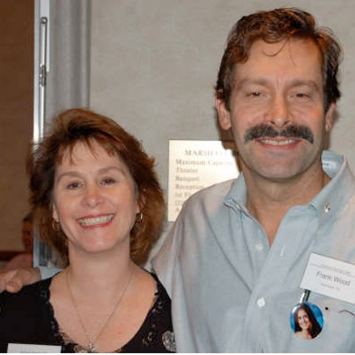
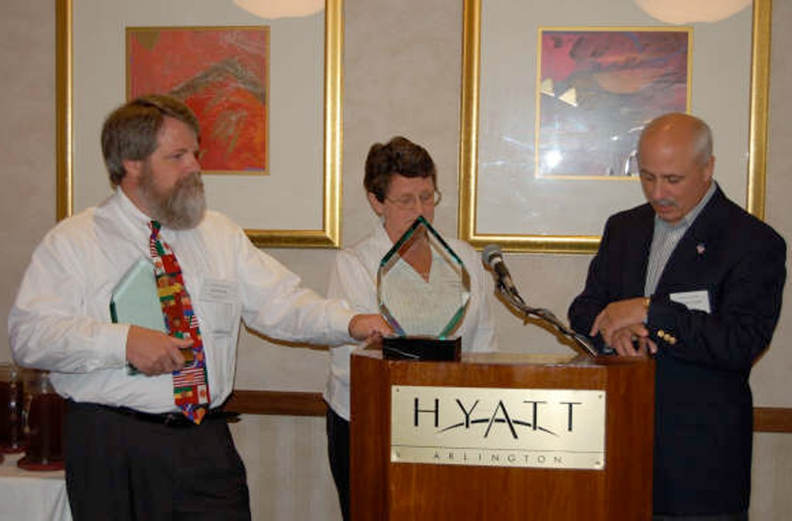

Agenda
Saturday, April 29th

10:00 – 10:15 am Welcome – TSC President Dawn King and TSC Vice President Jane Mathis
10:15 – 11:30 pm Introductions
11:30 – 12:30 pm Truck Safety Issues Panel
12:30 – 1:00 pm Handing out the schedules and break out to explain

1:00 – 2:30 pm Lunch (Catered by Hotel)
2:30 – 3:00 pm Grief Workshop
3:00 – 3:15 pm Break
3:15 – 4:30 pm Remembrance Ceremony
4:30 – 5:30 pm Open
5:30 – 7:30 pm Reception
Sunday, April 30th
10:00 – 11:30 am Social Media / Media Relations Workshop
11:30 – 1:00 pm Advocacy Panel
1:00 – 3:00 pm Lunch (Catered by Hotel)
3:00 – 4:00 pm Hill Meeting Preparation
4:00 – 5:00 pm Open
5:00 – 7:00 pm Dinner on Your Own in Old Town

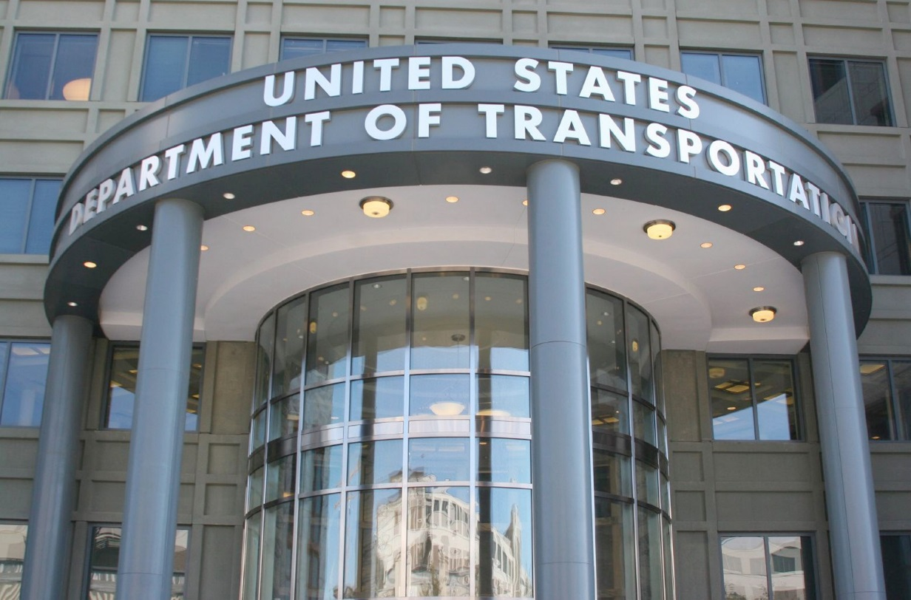
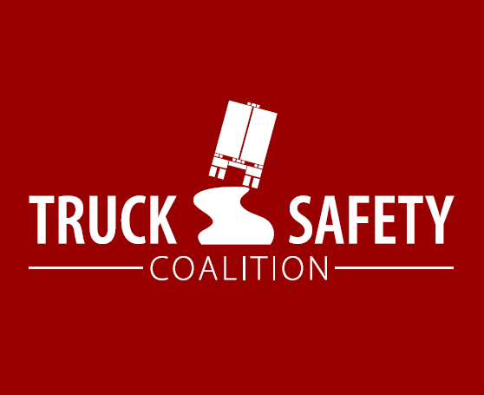

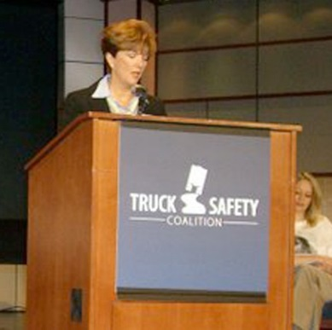

Agenda (cont.)

Monday, May 1st

9:00 – 12:00 pm Hill Meetings

12:00 – 1:00 pm Lunch

1:00 – 5:00 pm Hill Meetings
5:00 – 6:00 pm Lorien Hotel Reception (free/optional)
6:30 pm Optional: Share stories about your first day of Hill meetings –Dawn King and Jane Mathis invite you to meet in the lobby and walk together to dinner at a local restaurant.
Tuesday, May 2nd

9:00 – 11:00 am Hill Meetings

11:00 – 12:00 pm Press Conference

12:00 – 5:00 pm Hill Meetings
5:00 – 6:00 pm Lorien Hotel Reception (free/optional)

Wednesday, May 3rd (For those still in town)

9:00 am – 4:00 pm Hill Meetings

