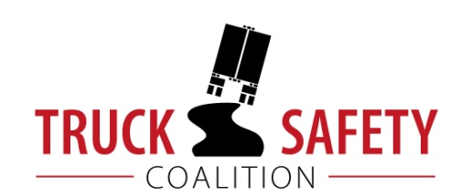

The Truck Safety Bulletin
June 2016

The Truck Safety Coalition (TSC) is a partnership between The Citizens for Reliable and Safe Highways (CRASH) Foundation, and Parents Against Tired Truckers (PATT). The Truck Safety Coalition is dedicated to reducing the number of deaths and injuries caused by truck-related crashes, providing compassionate support to truck crash survivors and families of truck crash victims, and educating the public, policy-makers and media about truck safety issues.
__________________________________________________________________________________________________________
Underride Roundtable Co-Hosted by TSC and IIHS Was a Success

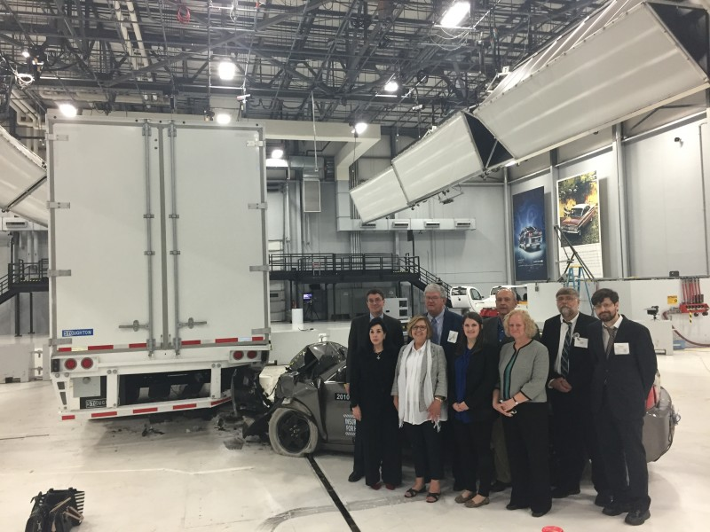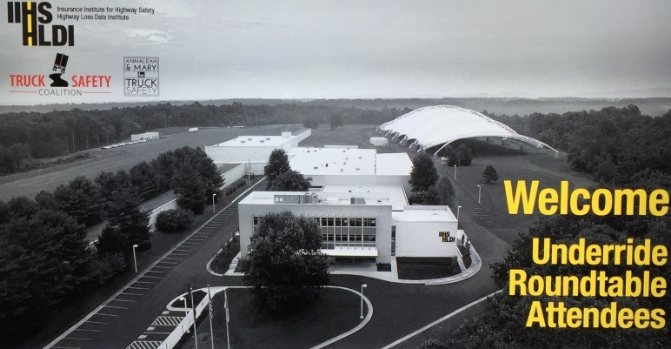

The Truck Underride Roundtable at the Insurance Institute for Highway Safety (IIHS), co-hosted by the Truck Safety Coalition and the Karth Family was a significant success. Interested parties, including safety advocates, industry officials, and government regulators came together to discuss the issue of truck underride crashes as well as possible solutions.

During the morning session of the event, attendees learned about the problem of rear and side underride crashes. Robert Mazurowski, an engineer for the National Highway Traffic Safety Administration (NHTSA), discussed how deficient trailer designs allow these crashes to occur. Then, the Director of the National Transportation Safety Board’s Office of Highway Safety, and truck crash survivor, Robert Malloy, illustrated the extent of the problem by presenting pertinent statistics about underride crashes. After that, Peter Kurdock, Director of Regulatory Affairs for Advocates for Highway and Auto Safety, detailed the 50-year regulatory history of underride guards.

The afternoon session focused on solutions. IIHS’s Senior Research Engineer, Matt Brumbelow gave an in-depth review of the research on improved guard performance and noted several trailers that currently exceed the insufficient standards now required by law. After this, several Virginia Tech engineering students presented a rear underride guard that they designed as their final project, and discussed the merit and drawbacks of several other guard designs.

Attendees also watched a crash test, in which a 2010 Chevrolet Malibu collided into the rear of a loaded truck trailer. The crash was ultimately a success. The guard prevents passenger compartment intrusion and the passenger would have survived the crash according to the dummy’s sensors and IIHS’s interpretation of the data.
See More Photos at: http://trucksafety.org/underride-roundtable-pictures/

After Decades of Delay, Entry Level Driver Training NPRM Released

On March 7, 2016, the Federal Motor Carrier Safety Administration (FMCSA) released a Notice of Proposed Rulemaking (NPRM) requiring training for entry-level commercial motor vehicle drivers. The Truck Safety Coalition welcomed this development in the effort to enhance truck safety. The NPRM is based upon negotiated rulemaking conducted by the Entry Level Driver Training Advisory Committee (ELDTAC).

While the Truck Safety Coalition looks forward to the safety benefits Entry Level Driver Training (ELDT) will produce, this important rule comes decades after a Congressional mandate requiring it. In that time, too many people have been injured or killed by inadequately trained truck drivers. Yet, despite the discouraging delays, TSC and our volunteers have remained committed to requiring this commonsense regulation.

Consequently, our Executive Director, John Lannen, and long-time TSC volunteer, Ron Wood, were selected to serve on the ELDTAC. Ron became involved in TSC after his mother Betsy Wood, sister Lisa Wood Martin and his sister’s three children, Chance, Brock and Reid Martin, were killed just outside Sherman, Texas in 2004. An untrained tractor trailer driver fell asleep behind the wheel and crossed a median into oncoming traffic on a busy North Texas highway. The driver collided with two vehicles, killing a total of ten people and injuring two more.

The History of Entry Level Driver Training
Date | Description
07/01/1980 | Motor Carrier Regulatory Reform and Modernization Act
10/30/1984 | Motor Carrier Safety Act
10/27/1986 | Commercial Motor Vehicle Safety Act
12/18/1991 | Intermodal Surface Transportation Efficiency Act
06/21/1993 | Federal Highway Administration’s (FHWA) Office of Motor Carriers (OMC) Releases ANPRM
01/01/2000 | Federal Motor Carrier Safety Administration (FMCSA) Replaces OMC
11/26/2002 | Owner Operator Independent Drivers Association (OOIDA), Advocates for Auto and Highway Safety (Advocates), and United Motor Coach Association (UMCA) File a Lawsuit Compelling FMCSA to Enforce ELDT Requirements
08/15/2003 | FMCSA Releases NPRM Proposing ELDT based on Adequacy Report Mandated by ISTEA
05/21/2004 | FMCSA Publishes Final Rule with No Behind-the-Wheel Training Requirement
12/02/2005 | Court Determines 2004 Rule to Be Arbitrary and Capricious Due to No BTW Requirements; Remands Rule to FMCSA
12/26/2007 | FMCSA Releases NPRM
07/06/2012 | Moving Ahead for Progress in the 21st Century Act (MAP-21)
09/14/2013 | FMCSA Withdraws NPRM
08/19/2014 | FMCSA Announces Consideration of Using Negotiated Rulemaking
09/18/2014 | Advocates, International Brotherhood of Teamsters, and CRASH Sue FMCSA to Require the Agency to Publish a Proposed Rule on ELDT in 60 Days and a Final Rule within 120 Days of the Court’s Order
11/26/2014 | Convener, Richard W. Parker, Recommends Negotiated Rulemaking
12/10/2014 | FMCSA Releases Notice of Intent to Establish Entry Level Driver Training Advisory Committee
05/29/2015 | ELDTAC Reaches Consensus on ELDT Provisions, Written Statement Release on June 15, 2015
06/12/2015 | Court Orders that the Petition for Writ of Mandamus Be Held in Abeyance Pending Further Order of the Court to Permit the USDOT to Issue, by September 30, 2016, Final Regulations Pursuant to MAP-21
03/07/2016 | FMCSA Release NPRM Based on ELDTAC Recommendations
As truck safety advocates, it was important that we had seats at the table so that we could voice our concerns with previous iterations of the ELDT rule and convey the urgency of requiring this lifesaving regulation by sharing accounts of people killed and injured by inadequately trained truck drivers. John and Ron helped ensure that, unlike previous versions, the final rule for Entry Level Driver training would include Behind-the-Wheel training in addition to a theoretical curriculum. We urge the FMCSA to move quickly on this NPRM and look forward to the safety benefits of a final rule.
Truck Safety Media
Join us on Social Media

If you haven't already joined us online, please like us on Facebook and follow us on Twitter. Social media is a huge part of our outreach strategy and we need all of you to help us. If we post something on Facebook, please like the post and share it as well. If we tweet something on Twitter, please retweet it. Having all of you sharing our social media posts will make a difference in how we can expand the reach of our safety message. If you would like to learn more about social media, click here to see a presentation from our conference.
Maine Voices: In the long haul, tired truck drivers result in hazardous highways
April 18, 2016

LISBON — As many of my fellow Mainers know, after my son Jeff was killed by a tired trucker in 1993, I founded Parents Against Tired Truckers and began advocating to make trucking safer.

In over two decades of educating the public and lawmakers about truck safety, I have also worked to ensure that regulations like maximum driving hours and mandated meal and rest breaks are implemented to improve work conditions for truckers and to prevent fatigue-related truck crashes.

The fact that a fatigued truck driver killed my son is not unique. One survey found that 65 percent of truck drivers reported being drowsy while driving and 48 percent admitted to having fallen asleep while driving. And according to the National Transportation Safety Board, fatigue is a probable cause, a contributing factor or finding in nearly 20 percent of their investigations between 2001 and 2012. Clearly, we should not be hindering the government’s efforts to set maximum hours and require rest breaks.

Instead, we should be looking at ways to change the industry culture, which promotes driving faster and farther, even if a driver is tired. Given that so many truck drivers are paid per mile, it is no wonder that the industry has created this culture, which ultimately rewards unsafe behavior.

However, there are clear signs that the industry must change its ways. Driver pay has effectively dropped by nearly a third since deregulation in the 1980s, and employment turnover rates constantly hover over 90 percent.

According to the National Institute for Occupational Safety and Health’s National Survey of Long-Haul Truck Driver Health and Injury, nearly 75 percent of long-haul truck drivers received an unrealistically tight delivery schedule, and nearly 40 percent of long-haul truck drivers reported violating hours-of-service rules. This is a consequence of shippers, brokers and motor carrier management forgetting that drivers are not merely assets, and that crashes are not merely the cost of doing business.

The hours-of-service rules were put in place to cap the maximum amount of hours truck drivers can work to ensure that they are adequately rested and can safely operate their vehicles. Yet there are many people, including our members of Congress, who misunderstand this.

The sad truth is that there are truck drivers who routinely work over 80 hours per week, and do so without actual weekends off. This is wrong, unsafe and a result of the industry’s relentlessly rallying against hours-of-service rules and successfully convincing lawmakers to ratchet up the amount of time truck drivers are allowed to work.

It is unfortunate that U.S. Sen. Susan Collins is once again behind an industry-backed measure to weaken hours-of-service rules and embolden unsafe driving behavior that contributes to countless preventable truck crashes. And it is equally unfortunate that the senator has made a tradition out of pushing the trucking industry’s agenda to weaken hours-of-service rules through the appropriations process, which bypasses any public input.

If she really believes that this is something that will make trucking safer and be supported by most Americans, then she should have a hearing and listen to the 80 percent of the public who oppose legislative efforts to increase the number of hours that semi-truck drivers are allowed to work in a week – not just to industry lobbyists.

As chairwoman of the Transportation, Housing and Urban Development Appropriations Subcommittee, Collins knows that such policy changes have no place in a spending bill. As a bipartisan senator, she knows that there are proven methods that she could work with Democrats to enact, like crash avoidance technologies and adequate underride protections.

And as a fellow Mainer, she knows of the tragic loss experienced by people like me; like Christina Mahaney, whose 5-year-old son Liam was killed in 2011 when a truck driver spilled a load of logs into the family’s Jackman home, and like the countless other parents, children, siblings, spouses and friends – loss that could have been prevented by stronger truck safety laws.

Ultimately, our lawmakers have a duty to address the issue of truck driver fatigue and take action to prevent needless truck crash deaths and injuries. Increasing a truck driver’s workweek from 70 to 82 hours will definitely not solve this problem, but allowing truck drivers to have a real weekend off by requiring a 48-hour restart will.

Daphne Izer
Founder
Parents Against Tired Truckers

Link: http://www.pressherald.com/2016/04/18/maine-voices-in-the-long-haul-tired-truck-drivers-result-in-hazardous-highways/
Get Your Story in the News

We want to help you get your story out in the local press. It is immensely helpful to have each of you remind your elected leaders, and the community at-large, of the dangers from unsafe trucking. The Truck Safety Coalition team is ready to help all of you with this effort. Please let us know if you want to send letters to the editor, or to pitch stories to reporters, and we will be glad to assist.
Interested in Interviewing?
Set up Skype.

Step 1: Go to Skype Website
Step 2: Click Device You Wish to Download Skype onto
Step 3: Save and Run the Skype Installation File (Click ‘Yes’ if Asked to Give Skype Permission)
Step 4: Select Your Language and Click ‘I Agree – Next’
Step 5: Click ‘Continue” (Check or Uncheck Boxes Based on Your Preferences)
Step 6: Skype Installs
Step 7: Create an Account (or Sign-In if You Already Have One)
Step 8: Send TSC Your Skype Name
Spotlight: The Higginbothams

Crash Account:
On November 18, 2014, Laurie’s son, Michael, was killed when his car crashed into a truck that was blocking the roadway near I-240 in Memphis. The truck had made an illegal U-turn across all lanes of traffic and cut in front of Michael’s car. The area was poorly lit and Michael was unable to see the truck in time. His car lodged under the side of the trailer and Michael was pronounced dead at the scene. The driver was cited for his negligence and received a mere $50 fine.
Truck Safety Issue:
Underride and Conspicuity
- Trucks with weak underride guards, or none at all, offer little to no protection for motorists or vulnerable road users
- Underride guards are below the bed of the trailer; their purpose is to prevent a motor vehicle, a bicyclist or a pedestrian from being run over by a large truck during a collision.
- Rear underride guards are required on many trucks and trailers, but the standard is antiquated and ineffective in preventing underride crashes from becoming injurious or fatal.
- Side guards are not required on large trucks and trailers, but they should be, given their success in the European Union.

A Word from Laurie and Randy:
The Truck Safety Coalition has been a tremendous resource after losing our son Michael.
TSC helped us, and Michael’s girlfriend Ashley, connect with other people who had experienced a similar loss of a loved one. There is a shared understanding of the suddenness of fatal truck crashes and the emptiness they cause.
Had we not attended TSC’s biennial conference in Washington, D.C., Sorrow to Strength, we would not have been exposed to this network of advocates that together greatly magnifies our voices in the pursuit of improved truck safety. At the conference, families of truck crash victims and truck crash survivors joined together to share why they became involved, identify truck safety deficiencies, discuss solutions to the issues, and then proceeded to educate the lawmakers about what they can do to reduce truck crashes and the resulting deaths and injuries.
We, along with Ashley, were also fortunate to attend the first ever Underride Roundtable, which brought together safety advocates, industry officials, and government regulators to talk about underride crashes and collaborate about methods to prevent them from occurring. Given that it was a lack of side underride guards that contributed to Michael’s death, this conference was especially important to us and proof that being a part of this organization can lead to action on the issues we care most about.
TSC relies on donations from people like us to make a difference in the lives of people dealing with a tragic crash. We invite you to donate directly to TSC’s PayPal account by clicking the “Donate” button found on their website ((http://trucksafety.org/get-involved/donate/). Your donation is tax deductible.
For those who want to take your fundraising efforts to the next level, please contact the TSC staff to coordinate a letter-writing campaign to your friends and family or to help you plan and host a fundraising event.
Sincerely,
Laurie and Randy Higginbotham

