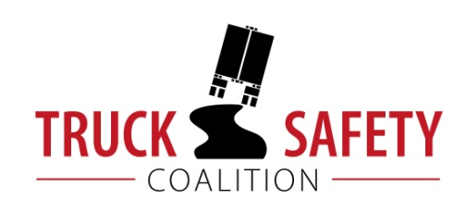

Parents Against Tired Truckers and Citizens for Reliable and Safe Highways

FACTS ABOUT THE DANGERS OF
LARGE TRUCKS IN WYOMING

- Between 2011 and 2015, there were 139 fatalities in crashes involving large trucks in Wyoming. (FARS)

- Twenty-one percent (21%) of Wyoming’s bridges are structurally deficient or functionally obsolete. (TRIP 2016)

- Nine percent (9%) of Wyoming’s public roads have pavements in poor condition. (ASCE 2017)

- Driving on roads in need of repair costs Wyoming motorists $138 million a year in extra vehicle repairs and operating costs – approximately $328 per motorist. (TRIP 2016)

KEY:
ASCE = American Society of Civil Engineers Report Card for America’s Infrastructure
FARS = Fatality Analysis Reporting System 2011-2014 Final, 2015 ARF
TRIP = The Road Information Program
NHTSA = National Highway Traffic Safety Administration, The Economic Impact of Motor Vehicle Crashes

