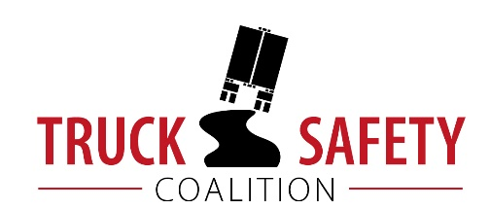

Parents Against Tired Truckers and Citizens for Reliable and Safe Highways

FACTS ABOUT THE DANGERS OF

LARGE TRUCKS IN PENNSYLVANIA

- Between 2011 and 2015, there were 803 fatalities in crashes involving large trucks in Pennsylvania. (FARS)

- Motor vehicle crashes cost Pennsylvania $6.54 billion per year, approximately $515 per capita. (NHTSA 2010)

- Thirty-two percent (32%) of Pennsylvania's public roads are in poor condition. (ASCE 2017)

- Forty percent (40%) of Pennsylvania’s bridges are structurally deficient or functionally obsolete. (TRIP 2016)

- Driving on roads in need of repair costs Pennsylvania motorists $4.8 billion a year in extra vehicle repairs and operating costs -- approximately $541 per motorist. (TRIP 2016)

KEY:
ASCE = American Society of Civil Engineers Report Card for America’s Infrastructure
FARS = Fatality Analysis Reporting System 2011-2014 Final, 2015 ARF
NHTSA = National Highway Traffic Safety Administration, The Economic Impact of Motor Vehicle Crashes
TRIP = The Road Information Program

