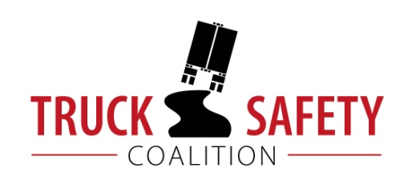

Parents Against Tired Truckers and Citizens for Reliable and Safe Highways

FACTS ABOUT THE DANGERS OF
LARGE TRUCKS IN IDAHO

- Between 2011 and 2015, there were 118 fatalities in crashes involving large trucks in Idaho. (FARS)

- Motor vehicle crashes cost Idaho $1 billion a year, approximately $638 per capita. (NHTSA 2010)

- Nineteen percent (19%) of Idaho’s bridges are structurally deficient or functionally obsolete. (TRIP 2016)

- Fifteen percent (15%) of Idaho’s public roads have pavements in poor condition. (ASCE 2017)

- Driving on roads in need of repair costs Idaho’s motorists $408 million a year in extra vehicle repairs and operating costs-- approximately $361 per motorist. (TRIP 2016)

KEY:
ASCE = American Society of Civil Engineers Report Card for America’s Infrastructure
FARS = Fatality Analysis Reporting System 2011-2014 Final, 2015 ARF
NHTSA = National Highway Traffic Safety Administration, The Economic Impact of Motor Vehicle Crashes
TRIP = The Road Information Program

